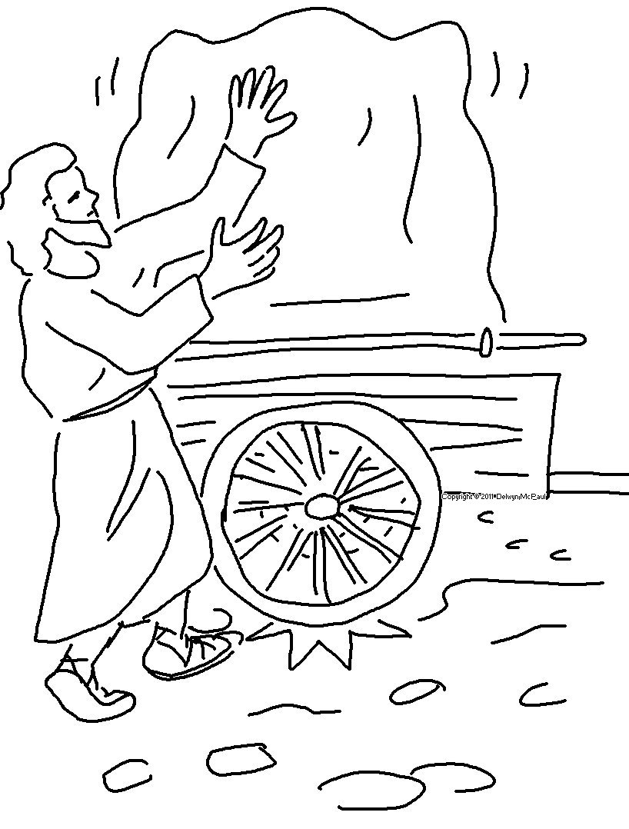
Lead me by your truth and teach me. Psalms 25:5_{NLT}

